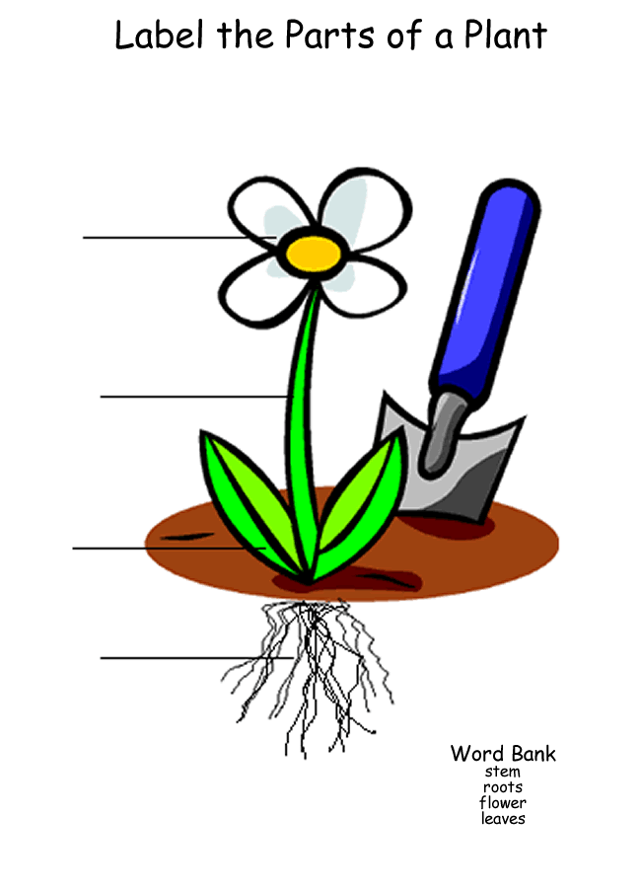

- stem
- root
- leaves
- flower

Use a word from the box
flower stem medicine living clothing
root flowers fruits leaves food

- The main parts of the plants are: ____________________, _____________________,___________________,___________________.
- Plants are part of ____________________ things .
- Plants produce ___________________ and _______________________.
- Plants are use for ___________________, ___________________, ___________________

